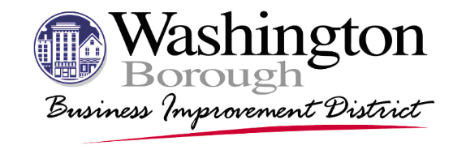
2024 Business Recognition Dinner
Advanced Registration
Date: Thursday, February 8th, 2024
Event Hours: 6pm-9pm
Location: Hawke Point Golf Club, 4 Clubhouse Drive, Washington NJ 07882

Full Name: __________________________________________________________________

Business/ Organization: ________________________________________________________

Email Address: _______________________________________________________________

Phone Number: _______________________________________________________________

Number of Tickets: _____________ x $60 = Total: __________________________________
Payments can be made via PayPal at http://WashingtonBID.org or by cash or check that can be
mailed or dropped off the BID office at 21 Belvidere Ave, Washington NJ 07882.

Names of All Attendees:

______________________ ___________________________

______________________ ___________________________

______________________ ___________________________

______________________ ___________________________

______________________ ___________________________

______________________ ___________________________

______________________ ___________________________

Completed forms can be mailed to the BID office or emailed to Admin@WashingtonBID.org

