2024 Pride Day Vendor Application

Date: Saturday, June 29th, 2024
Time: 10 am to 5 pm
Check in & setup: 8-9:30 m

Location: Downtown Washington Borough,
East Washington Avenue/Route 57,
Washington, NJ 07882 (Warren County)

Cost: Per 10x10 foot display space
- $20 - Advanced registration by April 26th, 2024
- $25 - Day of event, cash only, as space allows.
  - Payments can be made in cash or check mailed or dropped off to the BID office or paid via PayPal on the Steampunk Page on our website: www.washingtonbid.org

Checks and money orders should be made out to Washington BID and must be sent to our office to reserve your space:

Washington BID
21 Belvidere Ave
Washington, NJ 07882

All payments are final sale and are non-refundable. This event is rain or shine. There is a $60 returned check fee.

Registration: Registration by June 15th is strongly encouraged to ensure a space. We cannot guarantee spaces will still be available for same-day registration.

Applications can be mailed, e-mailed to admin@washingtonbid.org, or faxed to
(908) 689-8444.

For more information, visit us online at www.washingtonbid.org, phone (908) 689-4800, or e-mail an inquiry to admin@washingtonbid.org.
2024 Pride Day
VENDOR AGREEMENT & APPLICATION

- Requests for spaces are taken on a first come first serve basis, determined by postmark on application. However, final space assignment is at the BID’s discretion to accommodate overall event needs. Initial: _______
- Vendors must provide their own tables, chairs, covers, and provide a professional display. Initial: _______
- Vendor vehicles must be moved after loading to one of the municipal parking lots, unless previous approval is provided. Initial: _______
- There will be no subleasing of space. Initial: _______
- All promotions and giveaways must be approved by the WBID. Initial: _______
- Pending time restraints, vendors will be notified via email the week of the event regarding their spot assignment. Initial: _______
- I hereby give my consent to the WBID to use photos of myself or my products. Initial: _______
- Power, water, or any other utility is not provided by the WBID. Initial: _______
- This event is outdoors and is rain or shine. Initial: _______

Please fill out all the information below. This agreement is final between the Washington BID and the exhibitor upon signing.

Name, Please Print: ____________________________________________________

Signature: _________________________________________ Date: ____________

Business Name: _______________________ Cell Phone: _____________________

Email: _________________________Website: ______________________________

Mailing Address:
_______________________________________________________________________

Description of Exhibit: ________________________________________________________________________

*Please include two photos of your display/merchandise, which can be emailed to the BID: admin@washingtonbid.org

Will you be bringing a tent? ____Yes ____No

Are you a returning vendor in any WBID event? If so, please list previous events:

_____________________________________________________________________

Please write any additional comments here:

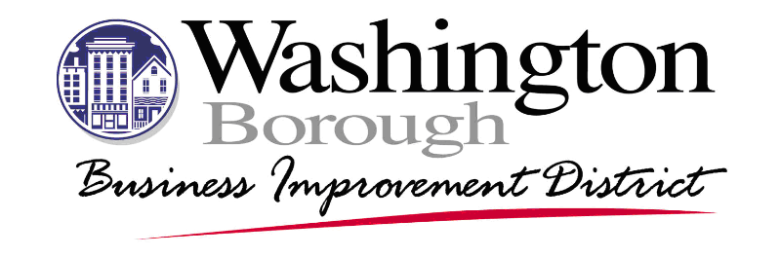

Vendor Waiver of Liability & Indemnification of Washington Borough BID

As a vendor, band, disc jockey, entertainer, performer, stilt walker, horse drawn conveyance operator, ride company/operator, etc. I understand that this waiver of liability must be signed in order for me to participate in the Washington Business Imporovment District’s (WBID) event. In addition I understand, and acknowledge, that my services will be provided only at the booth/stage site assigned to me (for fixed location vendors) or within the confines of the event’s geographic footprint (for roving/moving/mobile vendors) and may consist of some of the following examples of vending services: Art & Crafts sales, Food Vending, Not for Profit Fundraising activities, etc. Vending services covered by this waiver are not limited to the examples listed in the previous sentence, but include any and all vendor services provided in and during the WBID event.

I understand that in order to participate in the WBID event in any way, I must assume all responsibility & risk associated with all conditions, hazards, and potential dangers in, on, above, or about a site or location, whether they are open & obvious or concealed.

I hereby RELEASE, DISCHARGE, & WAIVE, any claims, actions or suits of any character, name & description, that I may have and INDEMNIFY the Washington Business Improvement District, the event coordinator, and its planning committee, agents, directors, officers & employees and owners/lessees of a booth site, surrounding areas, and retail establishments as a result of any injuries, damages, or death received or substained by me or passers by in connection with the vendor services performed on, in or while I am participating in the Washington Business Improvement District’s event.

I hereby agree to INDEMNIFY, DEFEND AND HOLD HARMLESS, The Washington Business Improvement District, the event coordinator, its planning committee, directors, board members, officers, agents and employees and owners/lessees of a booth site, surrounding areas, and retail establishments, from and against any and all liabilities, losses, claims, costs, expenses (including reasonable attorneys fees), damages, obligations, judgements or deficiencies of every/any kind and description, contingent or otherwise, resulting from or arising out of any of my acts or failure to act in connection with my services provided during the Washington Business Improvement District’s event identified below.

_________________________________ 2024 Pride Day
Vendor Signature Event Name

_________________________________
Vendor Name, Printed

_________________________________
Date Signed WBID DOC 6.04.15.ED.WOLI.101

