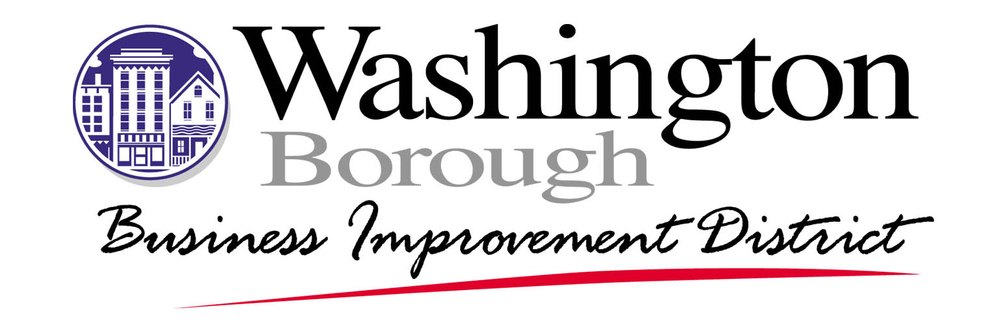

2025

SUMMARY

The Façade Improvement Program is an integral part of the comprehensive plan for the physical and economic revitalization of the Washington Business Improvement District, Washington, NJ.

Financial assistance is provided for exterior rehabilitation activities, including the following: complete façade renovation, new signs, awnings, and lighting.

The Program offers a grant for half the total cost up to $1,000 maximum for a façade improvement or sign listed above. All improvement plans are subject to the WBID Design Standards, review and approval by the WBID.

Your interest, support, and cooperation regarding the Façade Improvement Program are appreciated. If you have any questions, please contact the Washington Business Improvement District at 908-689-4800.

Address all correspondence to:

Melanie Thiel, Executive Director
Washington Business improvement District
21 Belvidere Avenue

Washington, NJ 07882
(908) 689-4800
mthiel@washingtonbid.org

INTRODUCTION

The Façade Improvement Program is designed to promote the revitalization of the Washington Business Improvement District by providing financial assistance to owners and tenants of commercial property for façade improvements. Financial assistance is in recognition of the significant impact that exterior building improvements have on the appearance and marketing of commercial properties and areas. Financial assistance is provided by the Washington Business Improvement District (WBID). This pamphlet provides an explanation of the program, including eligible expenditures and improvements, selection of applicants, procedural steps, design guidelines, and an application form.

LOCATION

The Façade Improvement Program is applicable to all nongovernmental properties located in the Washington Business Improvement District in Washington Borough.

ELIGIBLE EXPENDITURES AND IMPROVEMENTS

Expenditures and improvements under the Façade Improvement Program may include complete façade renovations, outdoor lighting, removal of aluminum and vinyl siding, replacement of window systems, new signs, and awnings fronting on a public space (i.e. public streets, parking lots, or parks). Tuckpointing and other major maintenance items may also be funded if they are included with other façade renovation work. Trash corrals, parking lot improvements and other site improvements may also be eligible if undertaken as part of a comprehensive façade improvement project and when visible from a street.

All proposed improvements and rehabilitation work will be subject to the design review and approval of the Washington Business Improvement District (WBID). Eligible projects must be in conformance with the following general criteria:

- The project is appropriate and support of goals of the program;
- The project is deemed as necessary renovation work that will result in a more attractive commercial property; and,
- The project is consistent with the Borough of Washington and WBID’s goals and planning concepts for the revitalization of the Washington Business Improvement District.

DESIGN CRITERIA

All building improvements must conform to the WBID Design Standards and Guidelines, and all Municipal Codes and Ordinances. All exterior building modifications will be subject to review and approval by the WBID, and the Borough of Washington if applicable.

PROGRAM PROCEDURAL STEPS

Step 1: Commercial business or property owner fills out application and
sends it to the Washington Business Improvement District.

Step 2: The application is reviewed, and a personal interview is scheduled
by the WBID staff with individual applicants to review preliminary
concepts developed by the applicant’s architect or contractor.

Step 3: Final plans, specifications, and detailed cost estimates are
submitted to the WBID accompanied by necessary municipal
permit applications.

APPLICATION FORM

- Property Owners Name: _______________________________________________

- Business Name: _______________________________________________________

- Business Address: _____________________________________________________

- Business Phone: _______________________________________________________

- Fax#: _________________________________________________________________

- Email Address: ________________________________________________________

- Names (s) of Business (s): ______________________________________________

_______________________________________________________________________

- Name (s) of Owner (s): _________________________________________________

_______________________________________________________________________

- Best Time and Person to Contact: _______________________________________

- Proposed Improvements (Facades, Signs, Lighting, Landscaping, etc.)

_______________________________________________________________________

_______________________________________________________________________

_______________________________________________________________________

_______________________________________________________________________

14. Amount requested: $ __________________________
The applicant, _______________________________________________, agrees to comply with the regulations of the Façade Improvement Program and the specific design recommendations of the Borough of Washington and the Washington Business Improvement District (WBID). Any changes in the approved plans or specifications must be presented to the WBID for approval.

I further understand that I must submit detailed cost documentation, including cancelled checks and bills, copies of Building Permits, and all contractors’ waivers of lien upon completion of the Façade Improvements Program, and execute a façade agreement with the WBID to assure property maintenance and the continuation of the approved façade or improvements and related plans.

Submit to: Washington Business Improvement District
21 Belvidere Avenue
Washington, NJ 07882
(908) 689-4800

Signature of Owner: __________________________________

Date: ____________________

Program Name | Facade Improvement (FI) Program
Program Description | The program is designed to assist small business owners, or commercial building owners in designated areas, to upgrade the exterior of their buildings including signage and security gates.
Eligibility Requirements
Geographic Area Served | Washington Business Improvement District
Targeted Population | Key structures that have location, historic, or social value.

Contact Information
Agency Name & Address | Washington Business Improvement District  21 Belvidere Avenue, Washington, NJ 07882  (908) 689-4800
Contact Person | Melanie Thiel, Executive Director
Telephone Number | (908) 689-4800
Fax Number | (908) 689-8444
E-Mail Address | mthiel@washingtonbid.org
Additional Information | Alterations to existing facilities must comply with WBID design guidelines, local building codes, and appropriate licenses and permits must be current. Approval by the WBID Architectural Review Board is required for loan consideration. All proposed projects must meet one or more of the following criteria: meet WBID Design Standards; contribute to the revitalization of WBID; be located in the WBID, be a member of the WBID Management Corp., and have a positive impact on the community.

