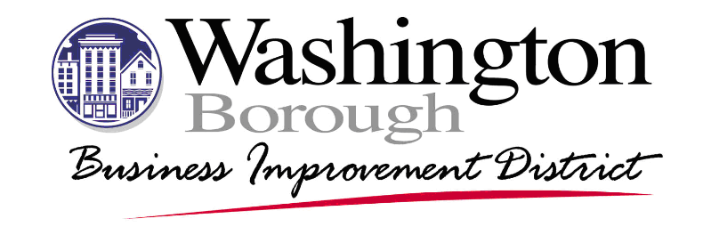

Washington Borough Business Improvement District
Accessibility Statement

Washington Borough Business Improvement District (Washington BID) is fully committed to ensuring that accessibility guidelines and requirements as set forth by the federal government and state of New Jersey are implemented in as timely and efficient a manner as possible.
Washington BID has been consistently responsive to making the arts accessible for all people with disabilities and will continue to strive to provide the utmost accessible experience possible. Through Washington BID programming, design, and service, we continue to reach out to and provide assistance and appropriate accommodation. If you need specific accommodations for an event or meeting organized by the Washington BID, please contact us with at least three weeks’ notice.
Washington BID is committed to exercising best practice and outreach in regard to employing persons with disabilities, both in artistic and administrative/operational areas.
Washington BID regularly reviews its policies and procedures to adapt, accommodate and address any issues or problems that might arise in regard to ADA compliance and will regularly assess its progress in achieving full compliance.

